Date: | Wednesday, January 15, 2025 | Type: | Virtual Zoom
Start Time: | 10:15 a.m. | End Time: | 11:40 a.m.
Leaders | Anthony Santella (Co-chair) Marianne Buchelli & Mitchell Namias (CT DPH Resource Liaisons)
Participants: | 8 | Next Meeting: | February 19, 2025

WELCOME AND INTRODUCTIONS
Anthony Santella opened the meeting by welcoming all participants and facilitating introductions.
APPROVE PRIOR MEETING SUMMARY
The group approved the summary of the November meeting. Ken Plourd took the opportunity to remind everyone about the new process for distributing meeting materials. Going forward, meeting agendas will be posted on the CHPC website (https://www.cthivplanning.org/needs-assessment-projects) one week prior to the meeting, and meeting summaries will be available one week after the meeting, and an email reminder will be sent one week post-meeting, directing attendees to the summary on the website.
NAP COMMITTEE 2025 (DISCUSSION ABOUT THE FUTURE OF THE COMMITTEE)
Anthony highlighted that the NAP Committee is undergoing a period of transition. The committee is not currently involved with a current needs assessment and its role in upcoming needs assessments related to the 2027 to 2031 plan development remains unclear . The group’s effectiveness is further challenged by low attendance rates and differences in subject matter expertise relevant to action items which hinder progress on goals and objectives. The CHPC Executive Committee will meet on January 23rd to discuss a proposal from the NAP Committee to rethink the charge of the NAP and/or its relationship to the Quality and Performance Measures (QPM) Committee. Should this proposal be accepted, an executive charter change will be required.
OPEN LETTER TO MEDICAL PROVIDERS
Marianne provided an overview of the Open Letter to Providers. She explained that the 2022 CTDPH Prevention Needs Assessment (PNA) survey results were analyzed by DPH scientists and then reviewed by both the CHPC and NAP Committee. Dr. Santella and DPH leadership collaborated with NAP members to draft a "call to action" Open Letter, informed by these survey results. The letter outlines recommendations for actionable steps by medical providers to enhance patient care and drive meaningful change. During the November NAP meeting, attendees reviewed and provided feedback on the letter, and NAP leadership will incorporate these suggestions into the final version. This letter will be presented to the CHPC at the February 19th meeting.
The group agreed that the letter’s signatories will include both CHPC/NAP leadership and Dr. Lynn Sousa. Luis Diaz from CTDPH will coordinate the distribution of the letter through multiple channels, including email, direct mail, in-person visits (sales-rep model), video, social media, and websites such as Positive Prevention CT and Ending the Syndemic. Luis also requested that Ken distribute the 2022 PNA Report via the CHPC listserv. Ken reminded the group that the report is also available on the CHPC website: https://www.cthivplanning.org/hiv-resources.
HOUSING RESOURCE
Ken discussed the housing resource created after the NAP Committee organized a 2023 panel featuring leaders from Connecticut housing organizations. This resource is a working document housed on the CHPC website and is designed as a quick reference guide for HIV Service Providers to link patients to housing options. However, during previous NAP meetings, concerns were raised about the limitations of the guide such as the accuracy of contact information due to staff turnover, incomplete information, and/or redundancy with existing resources such as 211.
The group agreed that continuously updating this resource would be challenging and may not create a high level of additional value. Instead, it was suggested that a more practical approach would be to develop a step-by-step guide for case managers to help individuals with immediate housing needs. This would allow case managers to use existing resources and relationships to identify housing options. Martina Cruz emphasized that the first step for any case manager seeking housing for a client is to call 2-1-1 to schedule an initial assessment.
Brian Moore noted clients who are referred to 2-1-1 may have to wait up to two days for housing—posing the question of where clients should go during that interim period. He also mentioned that housing availability and assistance differ by region within the state. Martina explained that some shelters and housing assistance centers receive special funding from the state to reserve space for “priority populations,” including people living with HIV. Despite this, she has experienced difficulties in ensuring priority for clients in this category. A housing resource guide does not address these issues. Providing tools for the case managers to problem solve may make more sense.
Mitchell suggested the formation of an ad hoc group, consisting of individuals with expertise in housing, to update and improve the CHPC housing resource guide. Ideally, this group could meet before the CHPC meeting on February 19th.
STIGMA INDICATOR
Stigma remains a significant barrier to accessing HIV prevention and care services and obstructs timely and effective treatment. Stigma contributes to poorer health outcomes, such as delays in linkage to care and challenges in achieving viral load suppression. Stigma has been integrated into Connecticut’s Integrated Plan, underscoring its relevance in the state’s comprehensive approach to HIV prevention and care.Goal 3 of the Plan seeks to "Reduce HIV-related disparities and health inequities." An objective under this goal area includes "develop" and incorporate at least one stigma and discrimination indicator into the CHPC indicator list by December 31, 2025.
The group reviewed a slide detailing 1) what current stigma indicators are being used in Connecticut, 2) future possibilities and opportunities in the state, and 3) the role of the NAP Committee in addressing these challenges.
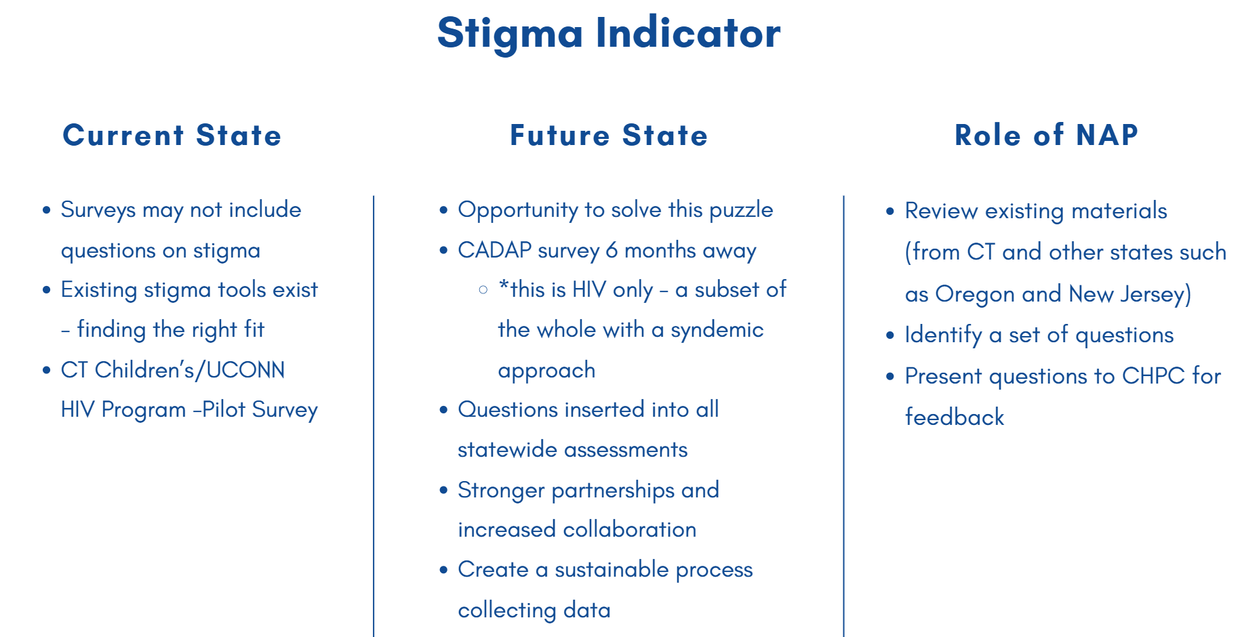

Anthony shared that in Oregon, stigma data is collected through the CDC-funded Medical Monitoring Project (MMP), designed to gather information from people living with HIV in 23 different project areas across the state. He proposed that Connecticut consider adopting the set of stigma-related questions used in Oregon’s survey. These questions include:
- During the past 12 months, I have been hurt by how people reacted to learning I have HIV.
- During the past 12 months, I have stopped socializing with some people because of their reactions to
my HIV status.
- During the past 12 months, I have lost friends by telling them I have HIV.
- I am very careful who I tell that I have HIV.
- I worry that people who know I have HIV will tell others.
- I feel that I am not as good a person as others because I have HIV.
- Having HIV makes me feel unclean.
- Having HIV makes me feel that I’m a bad person.
- Most people think that a person with HIV is disgusting.
- Most people with HIV are rejected when others find out.

Mitchell suggested that these or similar questions could be included in the upcoming PWH needs assessment survey through CADAP. This would represent a starting point to systematically measure stigma. Similar questions could be included in the next statewide HIV Prevention Needs Assessment too.

OTHER BUSINESS/ANNOUNCEMENTS
Mr. Santella reminded the group that he would be stepping out of his role as NAP co-chair. The group thanked him for his leadership over the past three years. Ken stated that NAP co-chair applications are available on the CHPC website. https://www.cthivplanning.org/

ATTENDANCE
Attendance records are kept on file with the CHPC support staff.
ADJOURN
The committee meeting ended at 11:40 a.m.

