Date: | Wednesday, January 15, 2024 | Type: | Virtual, Zoom
Start Time: | 10:15 a.m. | End Time: | 11:35 p.m.
Leaders | Dante Gennaro (MAC/PPCT Chair), Jenny Bobadilla-Pincos (CT Department of Public Health Resource Liaison)
Participants: | 9 | Next Meeting: | February 19, 2025

WELCOME AND INTRODUCTIONS
Dante Gennaro, chair of the joint MAC/PPCT committee, and Jenny Bobadilla-Pincos, the CT DPH Resource Liaison, welcomed everyone to the meeting. Mr. Gennaro invited participants to introduce themselves, sharing their name, pronouns, and, if applicable, the organization they represent. The co-chair emphasized the importance of a respectful and inclusive meeting environment. He reminded attendees of key guidelines, including:
- Allowing one person to speak at a time
- Raising a hand to indicate a desire to speak

ADMINISTRATIVE MATTERS
Workplan Overview: Mr. Gennaro provided a high-level review of the committee charges, emphasizing the work plans’ alignments with the overall Integrated Plan.
Committee Charge & Connection to Integrated Plan
- The Membership & Awareness Committee (MAC) leads CHPC member recruitment, selection, orientation, mentoring, and retention activities, and coordinates marketing and public awareness efforts.
- MAC activities relate directly to the Integrated Plan Goal 4: “Achieve integrated, coordinated efforts that address the HIV epidemic across community partners and interested parties.”
- The Positive Prevention Connecticut (PPCT) workgroup creates health communication and strategies for those populations at highest risk of getting HIV in Connecticut
- PPCT activities relate directly to the Integrated Plan Objective 1.1; “By December 31^{st,} 2026, increase awareness of PWH who know their HIV status to 93%.”; Objective 1.2; “Achieve a 25% decrease in new HIV diagnoses among MSM, Black men and women, and Latino men and women.”; Objective 1.3 “Expand Treatment as Prevention.”

MEMBERSHIP AND AWARENESS COMMITTEE (MAC)
Membership Goals (Broadening Our Definition Of Lived Experience)
The committee discussed ways to broaden representation on the CHPC by including individuals with lived experience outside of what has been traditionally considered, such as PrEP users and those with experience with STIs, substance use disorders, and mental health issues. This shift in the interpretation of lived experience aligns with the CHPC’s intent to implement a syndemic approach to preventing HIV (A syndemic approach to HIV means looking at how multiple health and social issues work together to make the impact of HIV worse for certain people or groups. It doesn’t just focus on the virus itself but also considers things like poverty, mental health, substance use, stigma, and discrimination, which can all overlap and make it harder for people to stay healthy).

Diversity and Recruitment Efforts
The committee discussed how the CHPC’s shift from a short-term annual member enrollment period (allowing people to apply and enroll during a select period yearly) to open/ongoing enrollment (allowing people to apply and enroll at any time) should help with engagement and attendance, and increase member diversity.
Mr. Gennaro stated that the CHPC must maintain a specific number of individuals with diverse backgrounds to represent the CT community. To fill existing gaps in CHPC membership, he mentioned that the CHPC is seeking young adults, transgender individuals, people with experiences related to substance use or the justice system, residents of Litchfield and Windham Counties, and individuals living with HIV.
- He reminded the group of the recruitment materials they voted on during their last meeting. While displaying the preferred recruitment document, he said that it would be used to enhance recruitment purposes. Ms. Bobadilla-Pincos added that the document must be approved by the DPH’s written material approval committee before sharing with funded sites for broad distribution.
Recruitment Material Poll Results
Option 2 was the preferred recruitment material with 29 votes
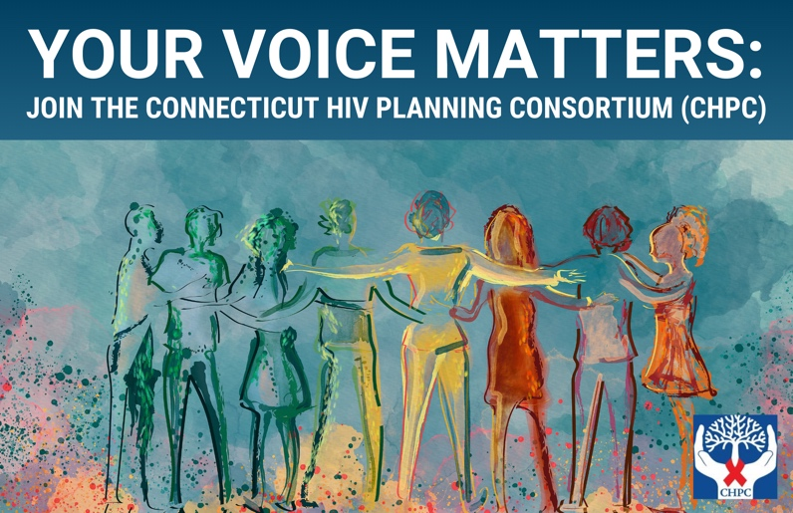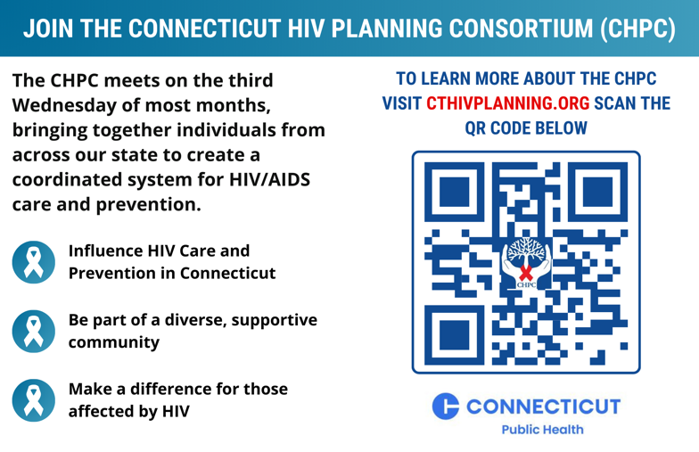
Newsletter Planning
Mr. Gennaro requested attendees to complete a poll to determine the group’s preferred topics for the upcoming newsletter. The group prioritized the following topics, which were generated at the November meeting (please see November meeting summary for additional insights per topic):
- Prevention Methods
- Stigma Reduction
- Living with HIV: Personal Stories
- Support for Undocumented Individuals
- Scientific Advancements
- Treatment and Support Services
- Housing Resources
- HIV and Pregnancy
- Link between HIV and Other STIs
- Conferences and Events
The topics in order from most to least prioritized (via selection in the poll) for the newsletter were:
- Living with HIV: personal stories (80%)
- Stigma Reduction (60%)
- Prevention Methods (e.g., PrEP, PEP) (60%)
- Scientific Advancements (40%)
- (Tied) Support for undocumented individuals, HIV and Pregnancy, Link between HIV and other STIs, Housing resources for PWH (20% each)
- (No Votes) Conferences and Events & Treatment and Support Services
Due to their apparent similarity, the committee merged the topics "Prevention Methods" and "Scientific Advancements" and decided to concentrate on the top four priority topics for the first newsletter. After merging two priority topics, elevating the importance of the link between HIV and other STIs due to its relevance to the CHPCs' syndemic approach, and deciding the Conference and Events topic could be featured as a list of upcoming events within the newsletter, the following topics for articles were identified:
- Living with HIV: Personal Stories
- Stigma Reduction
- Prevention Methods & Scientific Advancements
- The link between HIV and other STIs
Mr. Gennaro asked who would be willing to write an article for the upcoming newsletter. After a discussion of progress on existing articles and relationships with subject matter experts, the following volunteers emerged:
- Mr. Gennaro will leverage his connections with subject matter experts to write articles on Prevention Methods & Scientific Advancements and the Link Between HIV and other STIs.
- Mr. Reggie Knox will continue working with CHPC Support Staffperson Ken Plourd to document Mr. Knox’s personal story for the Living with HIV article.
- Ms. Bobadilla-Pincos volunteered to write the Stigma Reduction article focusing on people first language.
The group designated the February meeting as the deadline for the initial drafts of these articles.

PPCT UPDATES
Prevention Pack
Dante Gennaro provided an update on the ongoing Prevention Pack campaign, highlighting progress and next steps. The campaign, which centers around an anti-stigma audio series featuring superhero characters battling the villainous Dr. Stygma, has reached a significant milestone: over 75% of the raw audio recordings are complete.
Key updates and next steps include:
- Remaining Recordings: Two recording sessions must be scheduled to finalize the audio collection component, one with a primary character and one with a minor character.
  - Carl Ferris volunteered to fill in for the minor character if the original voice actor fell through.
- Production and Editing: The next steps include engaging an audio production specialist to finalize audio, create 30-second ads, and prepare the series for release.
- Distribution: The distribution plan includes local agency (funded site) social media, the New England AIDS Education and Training Center (AETC) podcasts, major podcast platforms, and the PPCT website.
The campaign is on track for completion by February 2025. At this point, the workgroup will initiate our next campaign initiative, which appears to be sponsoring a statewide contest to determine the best pro-condom messaging campaign.
Statewide Contest for Next Campaign
Mr. Gennaro proposed that the workgroup host a statewide pro-condom messaging campaign contest for its next campaign. The facilitator proposed an exciting contest initiative to attendees, outlining its phased approach and key goals to engage the community in generating compelling and community-tailored pro-condom messages. The framework for the contest would include the following phases:
- Planning and Launch (1/15 – 2/15)
  - Define submission requirements, judging criteria, and set up FAQ or Q&A for participants
  - Promote and launch the contest
- Submission Period (1/15 – 3/15)
  - Accept submissions of concepts for initial approval
- Initial Review (3/15 – 5/15)
  - Screen submissions for completeness and adherence to DPH and CHPC guidelines
    - Present participant concepts to the CHPC and DPH for feedback and approval
  - Engage diverse panel of judges, including MAC/PPCT membership
- Development and Test Launch (5/15 – 8/15)
  - Participants develop their campaigns and launch them in their respective regions
    - Track metrics
    - Collect feedback from public to guage campaign effectiveness
- Final Submission & Judging (8/15 – 9/15)
  - Participants submit completed campaigns, including engagement metrics
  - Convene a panel of judges and select winners
- Recognition and Incentives
  - Host an event to recognize participants and finalists
  - Provide prizes (ACT-funded gift cards and public acknowledgments)
  - Elevate winning team to statewide distribution
The workgroup supported pursuing this initiative as its next campaign.
Social Media Strategy
Ms. Bobadilla-Pincos reminded the group that PPCT is looking for a volunteer social media manager to assist in creating and sharing health campaigns aimed at CT’s populations most at risk for HIV. The volunteer would collaborate closely with her to ensure all posts comply with DPH guidelines. Key responsibilities would include suggesting posts on HIV updates, training sessions, campaigns, and related content. She mentioned that she contacted those who showed interest in the position during the last meeting but has not heard back from them, so the role is still open.

OTHER BUSINESS, NEXT STEPS, AND MEETING FEEDBACK
Integrated Plan Progress: Mr. Gennaro led a discussion to assess how 2024 activities align with the Integrated Plan objectives using the handout featured in Appendix A. The committee reviewed the handout to document progress on the 2022-2026 Plan objectives. The result of this discussion is summarized in the completed handout in Appendix A.

ATTENDANCE
Attendance records are kept on file with the CHPC support staff.

ADJOURN
The committee meeting ended at 11:35 a.m.

APPENDIX A
HANDOUT: Framework to Document Progress on 2022 to 2026 Plan Syndemic Strategies
Plan Obj | Plan Strategy | 2024 Progress by MAC/PPCT Committee Action Item
 |  | Newsletter | Community Engagement Days | CHPC Membership Protocol Enhancements | Statewide Campaigns | PPCT Promotion Items | Other
1.1.1 | Implement routine HIV testing and syndemic screening campaigns and other health promotion campaigns |  |  |  | R | R
1.1.2 | Build capacity of healthcare providers to implement routine HIV testing and screening |  |  |  | R
1.1.3 | Enhance community awareness and engagement efforts that increase knowledge equity about issues and available resources |  |  |  |  | R
1.2.2 | Recognize the status neutral care model as the standard for HIV-related services |  |  |  | R | R
1.2.3 | Expand access to PrEP and PEP
1.2.5 | Expand and enhance harm reduction services and recovery services to reach priority populations
1.2.6 | Advocate for the delivery of education- and community-based comprehensive sexual health education programs
1.3.1 | Implement and support awareness campaigns related to treatment as prevention |  |  |  | R | R
1.3.2 | Communicate to PWH and their partners the benefits of viral suppression to reduce HIV transmission |  |  |  | R
2.1.2 | Develop and implement a plan to improve referral processes that result in linkage to care
2.1.3 | Develop and pilot strategies to reduce internal and external stigma that affects decision-making to access care |  |  |  |  | R
2.2 | Develop a clinical provider inventory that lists capacity and capabilities to support referrals generated from routine HIV testing campaigns and update inventory annually
2.2.2 | Ryan White Part A partners establish rapid start standards and protocols for PHW to access safe, effective, and affordable medication
3.1.2 | Establish routine HIV testing and syndemic screening as the norm |  |  |  | R | R
3.1.3 | Encourage healthcare providers to comply with best practices and standards that promote patient empowerment, equity, and access |  |  |  | R | R
3.2.2 | Promote and/or coordinate trainings and events that address topics such as equity, cultural relevance, diversity, and inclusion
3.2.4 | Support continuous quality improvement and innovation to effectively engage priority populations |  |  |  | R | R
3.3.1 | Integrate the syndemic approach into the integrated HIV prevention and care plan
3.3.2 | Scale the status neutral care model |  |  |  | R | R
3.3.3 | Develop and implement a plan to improve referral processes that result in linkage to care
4.2.1 | CT DPH convenes Syndemic Partner Group
4.3.1 | Develop annual legislative agenda to address any policy-related matters

