Date: | Wednesday, November 20, 2024 | Type: | In-person, New Haven
Start Time: | 11:00 a.m. | End Time: | 12:15 p.m.
Leaders | Dante Gennaro (MAC Chair), Marcelin Joseph (PPCT Chair), Jenny Bobadilla-Pincos (DPH Resource Liaison
Participants: | 25 | Next Meeting: | January 15, 2025

WELCOME AND INTRODUCTIONS
Dante Gennaro and Marcelin Joseph, co-chairs of the newly merged MAC and PPCT Committees, welcomed everyone to the meeting. hey invited participants to introduce themselves, sharing their name, pronouns, and, if applicable, the organization they represent. The co-chairs emphasized the importance of a respectful and inclusive meeting environment. They reminded attendees of key guidelines, including:
- Allowing one person to speak at a time
- Raising a hand to indicate a desire to speak

COMMITTEE MERGER REMINDER
Mr. Gennaro and Mr. Joseph reviewed the recent merger of the MAC and PPCT committees, outlining the responsibilities of each group and how they will be addressed in the combined meetings. They introduced the new meeting structure:
- General Updates: Meetings will begin with updates relevant to both committees.
- Focused Discussions: Dedicated time for PPCT and MAC-specific projects will follow, and when necessary, will allow breakout rooms for smaller group discussions.

ADMINISTRATIVE MATTERS
Workplan Overview: Mr. Joseph and Mr. Gennaro provided a high-level review of the committee charges, emphasizing the workplans’ alignments with the overall Integrated Plan.
Committee Charge & Connection to Integrated Plan
- The Membership & Awareness Committee (MAC) leads CHPC member recruitment, selection, orientation, mentoring, and retention activities, and coordinates marketing and public awareness efforts.
- MAC activities relate directly to the Integrated Plan Goal 4: “Achieve integrated, coordinated efforts that address the HIV epidemic across community partners and interested parties.”
- The Positive Prevention Connecticut (PPCT) workgroup creates health communication and strategies for those populations at highest risk of getting HIV in Connecticut
- PPCT activities relate directly to the Integrated Plan Objective 1.1; “By December 31^{st,} 2026, increase awareness of PWH who know their HIV status to 93%.”; Objective 1.2; “Achieve a 25% decrease in new HIV diagnoses among MSM, Black men and women, and Latino men and women.”; Objective 1.3 “Expand Treatment as Prevention.”

CHPC Charter Updates: The discussion started with a focus on the challenges of the CHPC charter, specifically the annual membership recruitment, application, and onboarding processes, as well as the size range limitation of 25-33 members, since the CHPC is currently operating at the lower end of membership. This system limits the CHPC’s ability to fill vacancies promptly and maintain diverse representation as needed.
To address this, participants widely support a proposed shift to an open enrollment model, allowing continuous member applications and onboarding. Attendees agreed to submit this proposal to amend the charter to accommodate open enrollment to the executive committee.
Further discussions emphasized the need for more frequent onboarding to support open enrollment and gaps in diverse representation among the CHPC membership. Attendees suggested the following:
- Membership Tracking: Mr. Gennaro proposed creating a membership chart that is routinely reviewed to better monitor representation, identify gaps, and target recruitment strategies. Gina D’Angelo indicated that NAP had done this activity in the past and should consider revisiting it in the coming year.
- Onboarding Improvements: Nalicka Blair recommended holding at least two onboarding sessions annually, and attendees proposed creating and adding an onboarding orientation video to the onboarding package to streamline the process and make it more efficient for new members to get up to speed.
- Engagement and Public Participation: Danielle Warren-Dias noted that opening onboarding/orientation sessions to the public might be worthwhile in building community among members and reminding members of their responsibilities.
Concerns were raised about voting safeguards on the CHPC membership, particularly the potential of a group of members from a small organization to have an unbalanced influence over the CHPC.
- Angel Ruiz highlighted this risk, prompting Ken Plourd to explain the Executive Committee’s existing application review process, which ensures balanced representation.
- Attendees proposed formally integrating these safeguards into the CHPC bylaws to enhance transparency and fairness.

CHPC MEMBERSHIP AND RECRUITMENT STRATEGIES
The discussion shifted to CHPC membership and the development of recruitment strategies to attract underrepresented groups in the CHPC. Key focus areas included young adults, transgender individuals, people with substance use or justice system experiences, residents of Litchfield and Windham counties, and individuals living with HIV. The committee emphasized the importance of diversifying CHPC membership to better reflect and serve these communities.
Ken Plourd presented several recruitment flyer designs, which can be found at the end of this document, and invited feedback and invited feedback from attendees. Participants were encouraged to vote on their preferred design.
- Ms. Warren Dias recommended using higher-quality paper and index-card-sized materials, similar to cardstock party invitations, to improve accessibility, engagement, and durability.
- Mr. Plourd facilitated the voting process to ensure a fair selection of the top design.
Recruitment Material Poll Results
- Option 1: 3 votes
- Option 2: 29 votes
- Option 3: 12 votes

PPCT UPDATES
Prevention Pack: Marcelin Joseph provided an update on the ongoing Prevention Pack campaign, highlighting progress and next steps. The campaign, which centers around an anti-stigma audio series featuring superhero characters battling the villainous Dr. Stygma, has reached a significant milestone: over 75% of the raw audio recordings are complete.
Key updates and next steps include:
- Remaining Recordings: Five recording sessions must be scheduled to finalize the audio collection component.
- Production and Editing: The next phase involves contracting an audio production specialist to complete editing and mastering the series.
- Distribution: Episodes will be released through the New England AIDS Education and Training Center (AETC).
- Social Media Strategy: Prevention Pack materials will be promoted using a targeted social media campaign to maximize engagement and reach.
The campaign is on track for completion by February 2025. At this point, the workgroup will begin brainstorming and developing its next initiative.
Volunteer Social Media Manager Recruitment Announcement: Mr. Dante Gennaro announced that PPCT is recruiting a volunteer social media manager to support its mission of creating and disseminating health campaigns targeting CT’s populations most at risk for HIV. The volunteer would work closely with the DPH Liaison, Jenny Bobadilla-Pincos, to ensure all posts align with DPH guidelines. Key responsibilities would include recommending posts on HIV updates, trainings, campaigns, and related content. During the meeting, Mr. Jordan [Last Name] and Ms. Nalicka Blair expressed interest in applying.
Concerns About Feasibility: Mr. Mark Nickel raised concerns about the position’s feasibility, noting the significant time commitment required for responsibilities often handled by full-time staff in similar roles. Mr. Gennaro agreed, acknowledging that the role might be too demanding for a volunteer. This led to a broader conversation about strategies to improve the distribution and impact of PPCT campaigns.
Maximizing Campaign Reach:
- Video Content and Social Media Platforms: Ms. Danielle Warren-Dias suggested incorporating short, engaging videos and using platforms like TikTok to attract a broader audience. While Mr. Gennaro agreed on the platform’s potential, he noted the current lack of a dedicated TikTok account for PPCT or CHPC.
- Overcoming Regulatory Constraints: The discussion highlighted challenges posed by DPH regulations, which have previously delayed or restricted timely campaign promotion. Mr. Carlos Rodriguez suggested leveraging community agencies with fewer bureaucratic hurdles to share PPCT and CHPC campaigns instead.
- Future Recommendations: To address the ongoing challenges with social media promotion, Ms. Warren-Dias proposed incorporating social media management requirements into future Request For Proposals (RFPs) for agencies subcontracted by DPH.
Innovative Distribution Strategies
Further ideas emerged to enhance campaign accessibility and engagement:
- QR Codes: Participants proposed including QR codes on printed materials. This approach would provide direct links to online resources, reducing the need for lengthy or sensitive text on physical handouts while offering a more interactive experience for users.
- Influencer Partnerships: Building on successful models from other state agencies, the group discussed partnering with influences to expand the reach of HIV prevention campaigns.
Proposed Action Plan
Mr. Gennaro concluded the discussion by proposing a two-step action plan:
- Advocate for DPH to require funded social management roles or responsibilities in subcontracting agency agreements.
- Explore the feasibility of subcommittee partnerships with influencers to increase campaign visibility and engagement.

NEWSLETTER CONTENT BRAINSTORMING
The following content ideas were proposed to enhance the newsletter and provide valuable information to readers:
- Prevention and Treatment
  - Information about PrEP (pre-exposure prophylaxis), PEP (post-exposure prophylaxis), and Doxy PEP, highlighting their roles in preventing HIV transmission.
- Addressing Stigma
  - Anti-stigma messaging to reduce discrimination and prejudice associated with HIV.
  - Encouraging open conversations and fostering a supportive, inclusive environment.
- Living with HIV
  - Content sharing the experiences of people living with HIV.
  - Resources, support networks, and strategies for maintaining health and fulfilling lives after diagnosis.
- Support for Undocumented Individuals
  - Tailored information for undocumented individuals living with or at risk of HIV.
  - Guidance on overcoming barriers to care and accessing resources.
- Scientific Advancements
  - Updates on the latest scientific developments in HIV treatment, prevention, and research.
  - Content designed to position the newsletter as a reliable source of accurate and up-to-date information.
- Treatment and Support Services
  - Details on available treatment options and support groups for people living with HIV.
  - Empowering readers to make informed decisions about their care and connect with supportive communities.
- Housing Resources
  - Information on housing resources for individuals living with HIV.
  - Recognizing the critical role of stable housing in maintaining health and well-being.
- HIV and Pregnancy
  - Information on preventing mother-to-child transmission of HIV.
  - Addressing common concerns and misconceptions about HIV and pregnancy.
- HIV and Other STIs
  - Content exploring the link between HIV and other sexually transmitted infections.
  - Emphasizing the importance of comprehensive sexual health education and prevention strategies.
- Conferences and Events
  - Announcements about upcoming conferences and events for consumers.
  - Opportunities for learning, networking, and engaging with the HIV community.
Newsletter Distribution and Promotion: Attendees discussed ways to expand the reach and effectiveness of the MAC newsletter by using diverse distribution channels and strategies. Key suggestions included:
- Leveraging Multiple Distribution Channels:
  - Disseminate the newsletter through online platforms, social media, and partner organizations.
  - Expand the reach through direct distribution through trusted community networks.
- Improving Online Visibility:
  - Implement search engine optimization (SEO) techniques to increase the newsletter’s visibility in search results.
  - Ensure content is optimized with relevant keywords, engaging headlines, and shareable links.
- Encouraging Word-of-mouth Promotion:
  - Promote the newsletter among networks through word-of-mouth campaigns.
  - Leverage community connections to encourage readers to share the content within their networks.

PPCT PROMOTIONAL MATERIAL DISTRIBUTION
As the meeting concluded, Dante Gennaro reminded attendees that the PPCT is responsible for purchasing and distributing promotional materials, or “swag,” to promote HIV prevention and awareness campaign messages. The selected materials include:
- Collapsible bowls
- Electric hand fans with campaign messages displayed on the blades as they rotate
- Pens
- Sunglasses
- Collapsible hand fans
- Insulated backpacks or lunch bags, designed for individuals who may need to store medication in a temperature-controlled environment
The promotional materials feature the messages “Have you been asked?” and “Have you asked?”, which PPCT members chose earlier this year. These messages highlight Connecticut’s Routine HIV Testing Law, which requires healthcare providers to offer HIV testing to all patients aged 13 and older at least once as part of routine medical care. During annual check-ups, providers should inform patients about the availability of HIV testing and offer it as a standard practice.
Some materials were distributed to generate interest and awareness. The remaining items are stored at the Advancing Connecticut Together (ACT) Community Distribution Center and are available upon request to DPH-funded HIV Prevention sites. Interested organizations can submit requests through the following: https://act-ct.org//ccdcp.html.

ATTENDANCE
Attendance records are kept on file with the CHPC support staff.

ADJOURN
The committee meeting ended at 12:15 p.m.

APPENDIX A
Recruitment Item 1 – Option 1
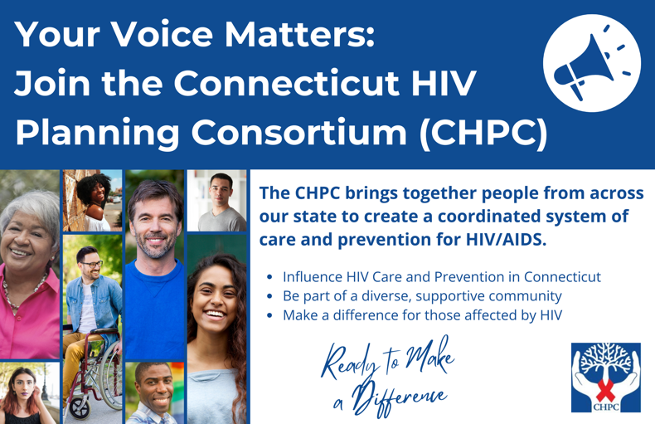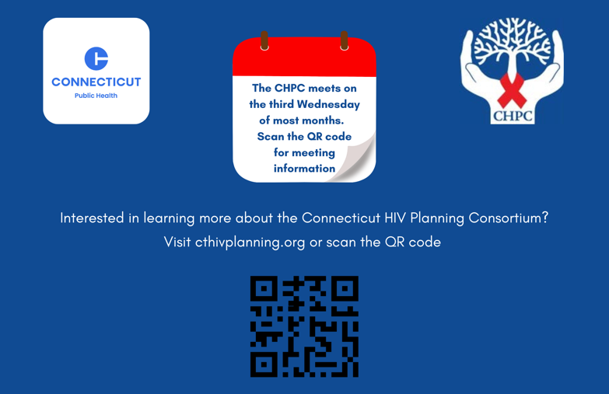

Recruitment Item 2 – Option 2
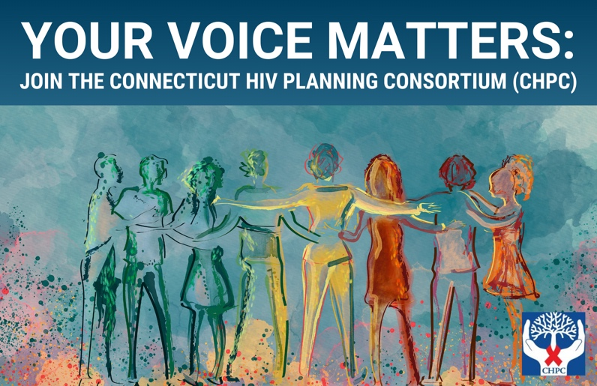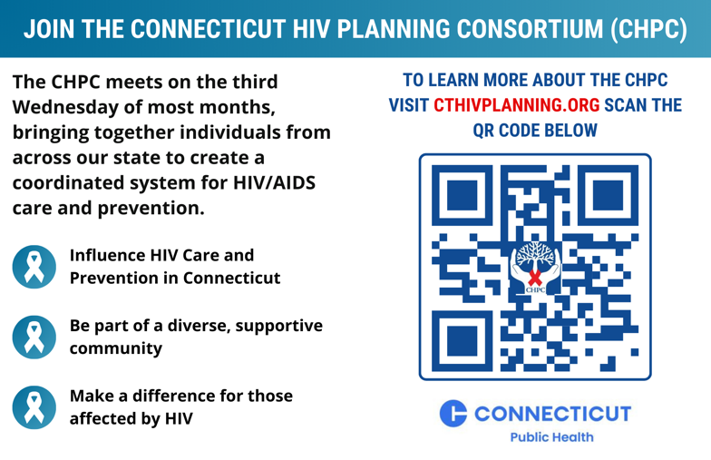

Recruitment Item 3 – Option 3
