|  |  |  |  |
| --- | --- | --- | --- |
| **Date:** | Wednesday, November 20, 2024 | **Type:** | In-person @ New Haven, CT |
| **Start Time:** | 9:10 a.m. | **End Time:** | 1:00 p.m. |
| **Participants:** | 121 | **CHCP Members:** | 21 |
| **Co-Chairs:** | Xavier Day, Nilda Fernandez, Africka Hinds | | |
| **Next Meeting:** | January 15, 2025 (meeting type and/or location to be determined) | | |

**WELCOME AND CHPC OVERVIEW**

CHPC Co-Chairs Xavier Day, Nilda Fernandez, and Africka Hinds welcomed participants to the in-person meeting at the Hotel Marcel in New Haven. They encouraged individuals to create a positive and interactive meeting environment and to be patient as everyone learns the nuances of a new space. The CHPC Co-Chairs reviewed the CHPC vision, mission, values, plan goals, and meeting objectives, and led a moment of silence – acknowledging the death of CHPC Member Jessica Figueroa.

**CHPC GENERAL BUSINESS UPDATES**

**October Meeting Summary.** Co-Chairs stated that the October meeting summary which was largely informational was approved by consensus.

**CHPC Website.** Participants were given a brief virtual tour of the updated CHPC website (cthivplanning.org).

**CONNECTICUT INTEGRATED PLAN 2022-2026**

**Update on Process to Align 2022-2026 Plan Goals with National HIV/AIDS Strategy and Gain Concurrence from CHPC and Ryan White Part A Planning Councils.** Africka Hinds shared that CT DPH and leaders from the Ryan White Part A Planning Councils and other federally funded Ryan White Partners met virtually with federal Project Officers from the Centers for Disease Control and Prevention (CDC) and the Human Resource Services Administration (HRSA). The federal Project Officers stated that they now will require Connecticut to align its goals with the National HIV and AIDS strategy. The CHPC received an update about this at the October meeting. The group developed a tentative process and timeline to secure approval for changes to the Plan goals (and indicators) as well as letters of concurrence from the CHPC and the Ryan White Part A Planning Councils. The table shows a tentative process and timeline that will be used as a starting point with the partners. The CHPC Co-Chairs and Executive Committee will guide and coordinate the communications process.

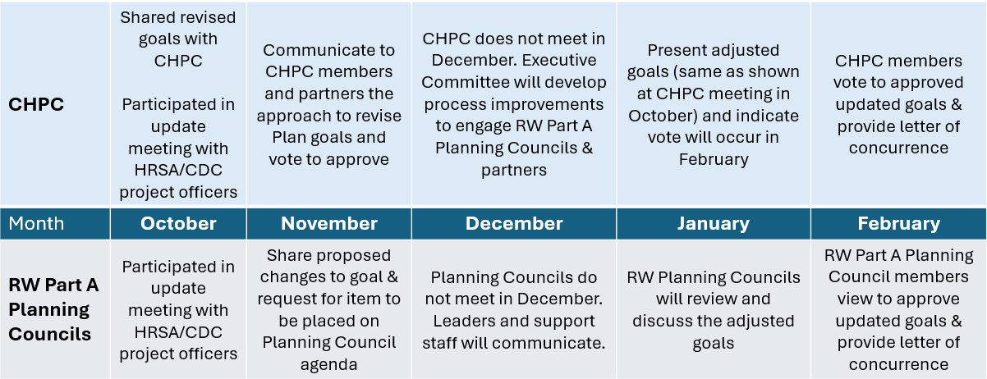

**Featured Topic: Interval House / Interpersonal Violence.** Mary-Jane Foster, President and Chief Executive Officer of Interval House – Connecticut’s largest domestic violence agency shared information about Interval House services, types of abuse, who is affected, domestic violence in the workplace, the connection of intimate partner abuse and HIV, how to help, and resources. Important resources include:

* Interval House: (860) 838-8467 (English) or (844) 831-9200 (Spanish)
* CT Safe Connect: (888) 774-2900
* National Domestic Violence Hotline: (800) 799-7233
* Partnership to End Human Trafficking: (203) 572-0407

Participants shared lived experiences and asked questions about how to support individuals who may be experiencing interpersonal violence and human trafficking.

**Short Video + Call for Ideas to Improve Engagement to and Connection with the CHPC.** Participants watched the premier of a short promotional video about the CHPC that features perspectives of CHPC members. The video will be available on the CHPC website and will support efforts to increase the visibility of the CHPC. Additional videos and social media content will be developed in the upcoming months from filmed interviews that will occur throughout the day. CHPC participants shared their immediate reactions to the video and suggestions for future topics and ways to increase visibility. Participants could attend the Membership and Awareness and Positive Prevention Connecticut Committee meeting for further discussion.

**CHPC Committee Meetings.** CHPC Co-Chairs reviewed the committee meeting schedule and areas of focus. Two committees will meet before lunch. The group will break for a 40-minute lunch and networking session. The final two committee meetings will occur after lunch. Meeting notes will be made available for each committee.

|  |  |
| --- | --- |
| **Committee** | **Areas of Meeting Focus** |
| Quality Performance Measures (QPM) | (1) Review Quality Improvement projects list and identify additional projects or unfinished business, (2) Priorities for 2025 workplan, (3) Activities to support 2027-2031 Plan |
| Ending the Syndemic (ETS) | (1) Review of current ETS projects and progress, (2) Gaps and needs to implement a whole-person approach, (3) 2025 workplan priorities |
| Needs Assessment Projects (NAP) | (1) Review letter to providers about Prevention Needs Assessment & distribution plan, (2) Review workplan and priorities for 2025 and committee structure, (3) Updates to housing resource |
| Membership and Awareness (MAC) & Positive Prevention Connecticut (PPCT) | (1) Membership gaps and recruitment, (2) PPCT updates on promotions and social media manager, (3) CHPC newsletter development |

**NEW BUSINESS AND ANNOUNCEMENTS**

No new business was introduced. Participants shared announcements throughout the meeting and were encouraged to send information to CHPC support staff members for distribution to the CHPC contact list.

**MEETING FEEDBACK**

Participants completed the monthly meeting feedback forms to share their experiences and to suggest areas for improvement in future meetings.

**ADOURN**

The CHPC Co-Chairs adjourned the meeting at 2:00 p.m.

**ATTENDANCE**

Attendance records are kept on file with the CHPC support staff.